Nama : Wahyu Indrawan

NIM : 18090108

Kelas : 5D

Laporan Praktikum 2

1. Source Code

Model_latihan1.php 🡪 application\models

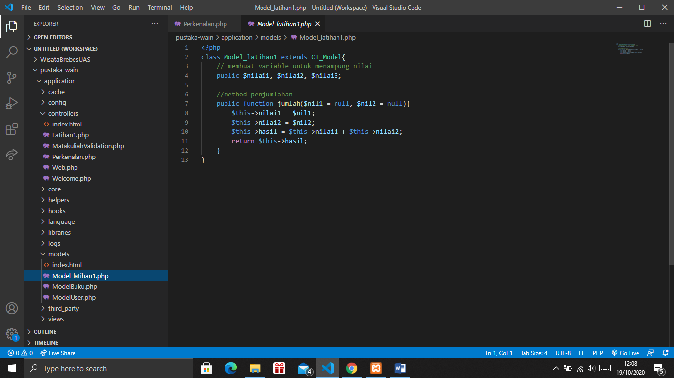

Latihan1.php 🡪 application\controllers

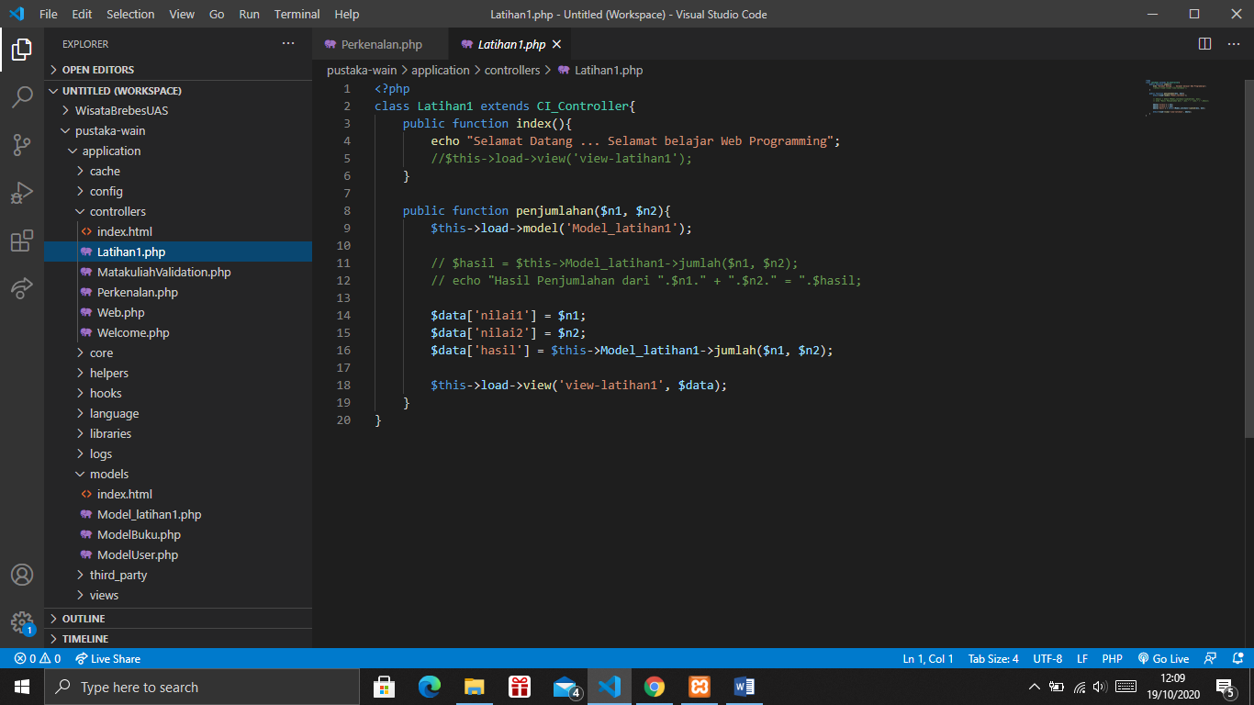

View_latihan1.php 🡪 application\views

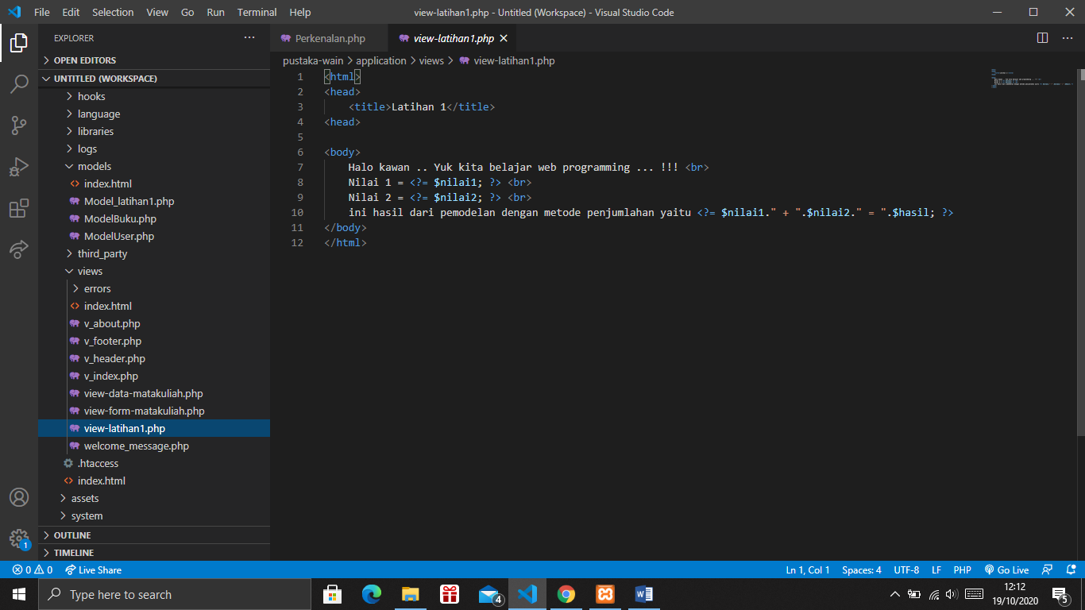

1. URL

<http://localhost/pustaka-wain/index.php/Latihan1>

http://localhost/pustaka-wain/index.php/Latihan1/penjumlahan/8/9

1. Capture Output Program

